**MN Association for Career and Technical Administrators**

##### Fall Conference ~ September 28-30, 2011

### Arrowwood Resort & Conference Center Lodging Form

TWO NIGHT Group Package ( Select One)

___ **$315.66 Single Occupancy Per Person, Entire Stay Inclusive**

___ **$215.20 Double Occupancy Per Person, Entire Stay Inclusive**

**The Package includes**: Overnight Accommodations for Wednesday and Thursday Night, Breakfast, Morning Break, Lunch, Afternoon Break and Dinner on Thursday, Breakfast, Morning Break and Box Lunch on Friday, Tax and Gratuity.

ONE NIGHT Group Package – Wednesday Arrival

___ **$144.84 Single Occupancy Per Person, Entire Stay Inclusive**

___ **$94.79 Double Occupancy Per Person, Entire Stay Inclusive**

**The Package includes**: Overnight Accommodations for Wednesday Night, Breakfast, Morning Break and Lunch on Thursday, Tax and Gratuity.

ONE NIGHT Group Package – Thursday Arrival

___ **$167.46 Single Occupancy Per Person, Entire Stay Inclusive**

___ **$117.41 Double Occupancy Per Person, Entire Stay Inclusive**

**The Package includes**: Overnight Accommodations for Thursday Night, Dinner on Thursday, Breakfast, Morning Break and Box Lunch on Friday, Tax and Gratuity.

** **Arrowwood will not assign Roommates.** If you check Double Occupancy, each person must submit a Registration Form to make their own reservation. Please list Roommates name below:

**_______________________________________________________**

COMMUTER MEAL PACKAGES :

**___** $113.12 Per person Inclusive

**The Package includes**: Breakfast, Morning Break, Lunch, Afternoon Break and Dinner on Thursday, Breakfast, Morning Break and Box Lunch on Friday, Tax and Gratuity.

**MAIL, FAX or EMAIL ENTIRE FORM TO:**

**Arrowwood Resort & Conference Center**

**2100 Arrowwood Lane NW**

**Alexandria, MN 56308**

**FAX: 320-762-0133**

**kwallisch@arrowwoodresort.com**

NO RESERVATIONS ACCEPTED WITHOUT FORM

**PREFERRED LODGING HELD UNTIL**

### September 9, 2011

Mr./Mrs./Ms.______________________________________

Street___________________________________________

City _______________________________ St ___ Zip_____

Day Phone (______)___________

Eve Phone (_____)____________

Arrival Date:___/___ Departure Date___/___ #Nights_____

**Special Requests:** (i.e. Room accessibility, dietary, etc.)

Explain:__________________________________________

** **All of our guestrooms are non-smoking.**

**METHOD OF PAYMENT**

___ Check-**Must be sent with form**

___ Credit Card

VISA MC DISCOVER AMEX

Card # _____________________________________ Exp._____/_____

Cardholder’s Name: _________________________________________

Signature: _________________________________________________

**CANCELLATION POLICY**

# **LABOR DAY - MEMORIAL DAY**

Our cancellation policy is 72 hours **prior** to your arrival. We will charge your credit card for the entire package price if the cancellation is made within 72 hours of your arrival. If payment is made by check, we will refund your money only if the cancellation is made 72 hours prior to your arrival.

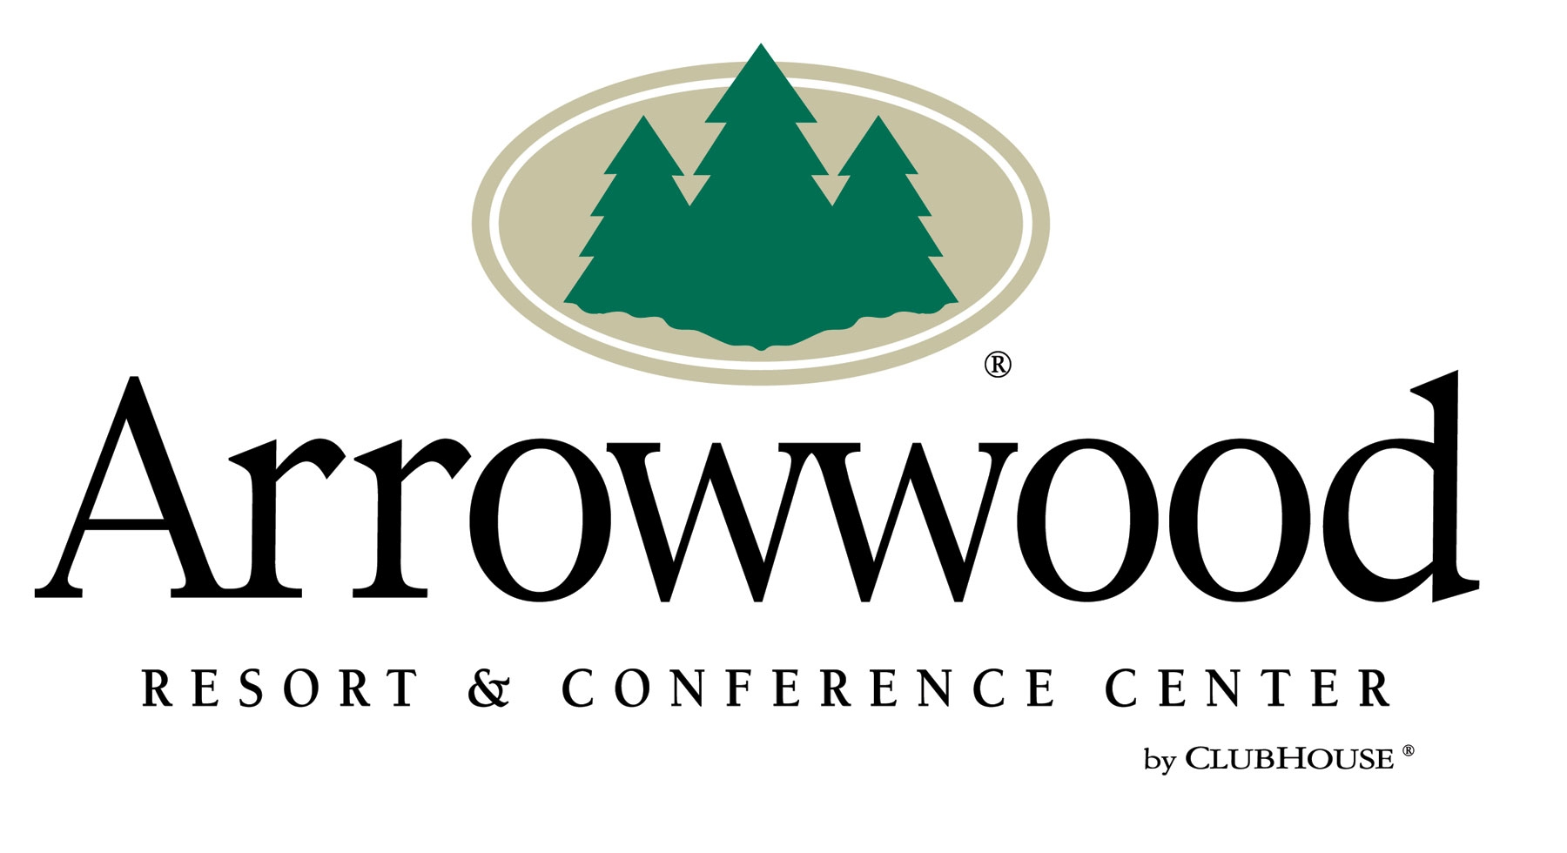

***CHECK-IN TIME IS 4 P.M./CHECK-OUT IS 12:00 PM.***