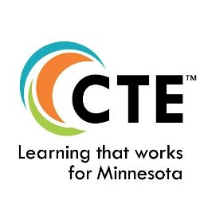 Minnesota Association of Career and Technical Education

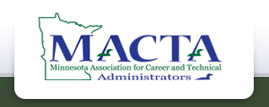
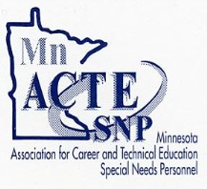
MnACTE Newsletter Debbie Larson, President
I have added following corrections to my previous newsletter from feedback I received. I will try and do updates as I receive them. If you have additional information that you would like to share with our membership, please forward it to me.
Jeralyn Jargo has ask me to add the Minnesota State logo, with a short message, to our partnerships and Max Peterson has provided an updated list of MDE representatives.
Minnesota State:
Jeralyn Jargo: System Director of Career Technical Education Minnesota State
www.minnstate.edu
jeralyn.jargo@minnstate.edu | 651-201-1650
Message from Jeralyn:
We, Minnesota State, have the list serve, are the sole source agencies for Perkins funds, have the mentor/mentee leadership initiative, etc.

MDE representatives:
- Director – Office of Career and College Success Paula Palmer
- Supervisor – Career and Technical Education Michelle Kamenov
- Agriculture Education Specialist/CTE levy Joel Larson
- Family and Consumer Science Specialist/CTE Works! Summit Maxine Peterson
- Trades, Industry, and Technology Specialist John Rapheal
- Career Development – Work Based Learning April Schnell
- Evaluation Specialist II – Results Measurement Kari-Ann Ediger
- Business and Marketing Vacant
- Health and Human Services Vacant
- Perkins - Administrative Support Deb Blahosky
- Levy – Administrative Support Jennifer Norton
- MCIS Specialist Beth Haukebo
- MCIS – Specialist and Trainer Dorothy Wolf
- MCIS – Administrative Support Deb Parkos

