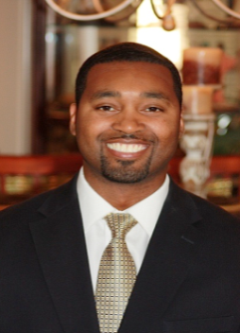
Deon Clark is the Chief Executive Officer of TCI Solutions, LLC; a certified veteran and minority owned business committed to providing the highest quality of consultation in three key areas: Workforce Talent Pipeline Development, Corporate Diversity - Inclusion and Engagement Strategies, and Educational Development Services for Teachers & Students. He also serves as Chairman of the Board for The Legacy Initiative, a nonprofit organization whose student development programs have assisted over 5,000 students across 5 states with personal and academic excellence.
Mr. Clark served for over 8 years in the United States Navy as a Nuclear Plant Operator, Mechanic and Instructor. In the commercial energy sector, he spent time as a Licensed Senior Nuclear Reactor Operations Instructor, and also served as an HR consultant to assist in attracting and retaining top diverse talent. He is the creator of the Legacy Iᶟ Workforce Transformation and Economic Development Model, a talent creation system that serves as an incubator for local, diverse, high quality workforce candidates.
Mr. Clark has developed robust talent development systems for major US companies such as Xcel Energy and Arizona Public Service Company. He has provided training to, and led numerous high level meetings and discussions around workforce and talent development for major organizations to include: The Center for Energy Workforce Development, The Western Apprenticeship Coordinators Association, The Nuclear Energy Institute, The American Gas Association, The US Department of Energy, The American Association for Blacks in Energy, The United Way Worldwide, Minnesota State Colleges and Universities, University of North Georgia, The Southern Company and countless others.
Mr. Clark earned his B.S. in Human Resource Management form the New School University in NY, NY. He earned his Senior Nuclear Reactor Operator Instructor Certification from the LaSalle Generating Station in IL.

