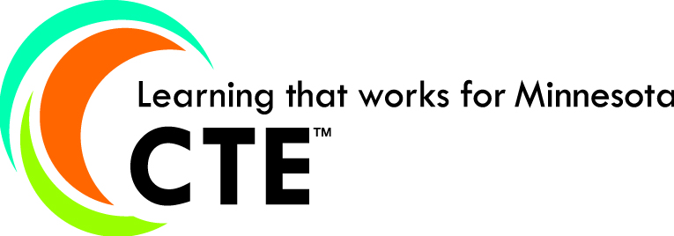
CTE Talking Points

Minnesota State Colleges and Universities and Minnesota Department of Education
Mission
Rather than develop a CTE mission and a vision statement, Minnesota built its State Plan around seven guiding principles:
- CTE and academic/general education must be integrated in a more comprehensive way.
- College and work readiness skills are one and the same.
- Each student needs at least some education or advanced training past high school, whether 2-year college, 4-year university, industry certification, or advanced training through work.
- Federal Perkins funding for CTE is not an entitlement at either the state or local level.
- All education spending must be connected with student success outcomes.
- High schools and colleges should continue CTE programs and activities that have worked well.
- CTE must be strategically placed within the broader vision, mission and goals for education within the state of Minnesota.

What is CTE?
Career Technical Education (CTE) provides high school students and adults with the academic/general education and technical skills, knowledge and training necessary to succeed and to develop skills they will use throughout their careers. CTE programs are organized into 16 career clusters that identify the common core outcomes students need as they follow a pathway to their goals. CTE prepares students for the world of work and to be globally competitive by introducing them to workplace competencies, and makes academic/general education content accessible to students by providing it in a hands-on context.

Minnesota CTE Goals

Development of Programs of Study/Career Pathways

Partnerships with business, industry, agencies, and community and educational organizations

Success for all students, including special populations

Continuum of service and transitions for students

Local consortium and regional planning for effective use of resources to meet regional workforce needs

CTE Enrollments
In Minnesota, 223,833 secondary and postsecondary students were enrolled in career technical education courses in 2014—122,980 students took career technical education courses at the Minnesota State Colleges and Universities and 100,853 students took courses at public high schools.

CTE Students
CTE students are of all ages-youth to adult-and come from a wide range of backgrounds and experiences. CTE students can take courses in secondary schools and transition into postsecondary colleges through a program of study in one of 16 career clusters. Adult CTE students, including working learners, dislocated workers, adult basic education students, English language workers and others enroll in colleges to advance their skills and earn more credentials within an adult career pathway in the same 16 career clusters www.careertech.org. CTE Learning that Works--Minnesota joined fifty other states in launching a national campaign to further highlight the benefits of CTE programs and careers. The campaign is primarily directed at students. Career information for the student audience highlights student stories, career pathways information www.learningthatworks.org.

CTE Works! A Minnesota Summit on Career Technical Education
The annual summit showcases best practices in career technical education across the state of Minnesota. It is attended by over 325 CTE teachers, faculty, counselors, advisors, administrators and business industry leaders. www.cte.mnscu.edu/professionaldevelopment/index.html

Student Success and Workforce Preparation
- High School Graduation Rates--Reducing the graduation gap in MN: The goal for the state of MN is to reduce the achievement gap by 50 percent by 2017, including the graduation gap. The 4-year graduation rate (Class of 2013) for all students in MN is 79.8%. For CTE Concentrators who complete 240 or more CTE course hours within one Career Field, the 4-year graduation rate (Class of 2013) is 90.2%. For CTE Concentrators, this represents an overall increase of 2.2% from the previous year. Compared with previous year’s outcomes, the NCLB 4-year graduation gap for African American CTE Concentrators was reduced by 8.5%, followed by Asian/Pacific Island CTE Concentrators 5.1%, and Hispanic Concentrators 2.3%.There was an overall 8.7% increase in the 4-year graduation rate for English Language Learners (82.2%), a 3.7% increase for Economically Disadvantaged students (83.3%), and a 3.0% increase for Individuals with Disabilities (72.4%).For each CTE Concentrator student group, the 2013-14 graduation rate is African American 77.2%, American Indian 74.0%, Asian/Pacific Island 88.6%, Hispanic 81.2%, White 92.2%.
- 84 percent of college CTE students were placed or retained in employment, military service or apprenticeship by the end of the second quarter following the year they completed a CTE program [Based on students entering a state college in FY2011 and receiving an award within three years]
- 78 percent of college students concentrating in CTE graduated or continued their education—46 percent earned a CTE award, a certificate, diploma or associate degree within three years and 32 percent were retained or transferred to a two year college or four year university. [Based on students entering a state college in FY2012 and followed for three years.]
- Over 22,000 CTE awards were earned by college graduates in FY14 —10,022 associate degrees (AAS/AS), 5,198 diplomas and 6,906 certificates. [preliminary ISRS awards data for FY2014]
- CTE prepares students for some of the fastest growing jobs forecasted to rise in coming years, such as health care, business, arts, agriculture, information technology, and construction. “Careers with the Most Openings in Minnesota” www.iseek.org/careers/highdemand
- Experts project 66 million job openings in the U.S. and 901,600 job openings in Minnesota in the decade ending in 2022. About 12 percent will require an associate’s degree or certificate and nearly all will require real world skills that can be mastered through CTE. www.positivelyminnesota.com/apps/lmi/projections/

Perkins funding
The FY15 Carl D. Perkins Career and Technical Education Act award to MN totals $16,684,637 or almost $17 million. Of that $14.2 million goes to 26 local consortia of public colleges and high schools to benefit all members of the consortium. ($8.2 million is allocated on the basis of college Pell grant recipients and $6 million on the basis of population of 5-17 year olds within a consortium and the percentage of those 5-17 year olds in households of poverty.) Of the $14.2 million to local consortia, $1.4 million is reserved to benefit rural students and/or high participation programs.

Programs of Study
Local consortia across Minnesota have created programs of study in career pathways that identify courses for students to take in high school, transitions to postsecondary education, occupations within a career pathway, industry certifications, and opportunities for dual or concurrent enrollment in high school and college. Visit www.MNProgramsofStudy.org

Pathways to Postsecondary Summits
The Minnesota Department of Education and Minnesota State Colleges and Universities crisscrossed the state in October, 2014 through February, 2015 to host regional summits engaging secondary and postsecondary teams. A total of 846 superintendents, principals, teachers, counselors, college presidents and faculty gathered to deepen common understandings of newly-enacted legislation, examine workforce trends and explore opportunities for new or expanded partnerships between educational systems that will better prepare our continuum of learners to be career and college ready.

